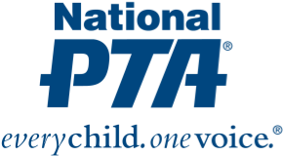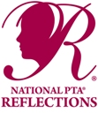

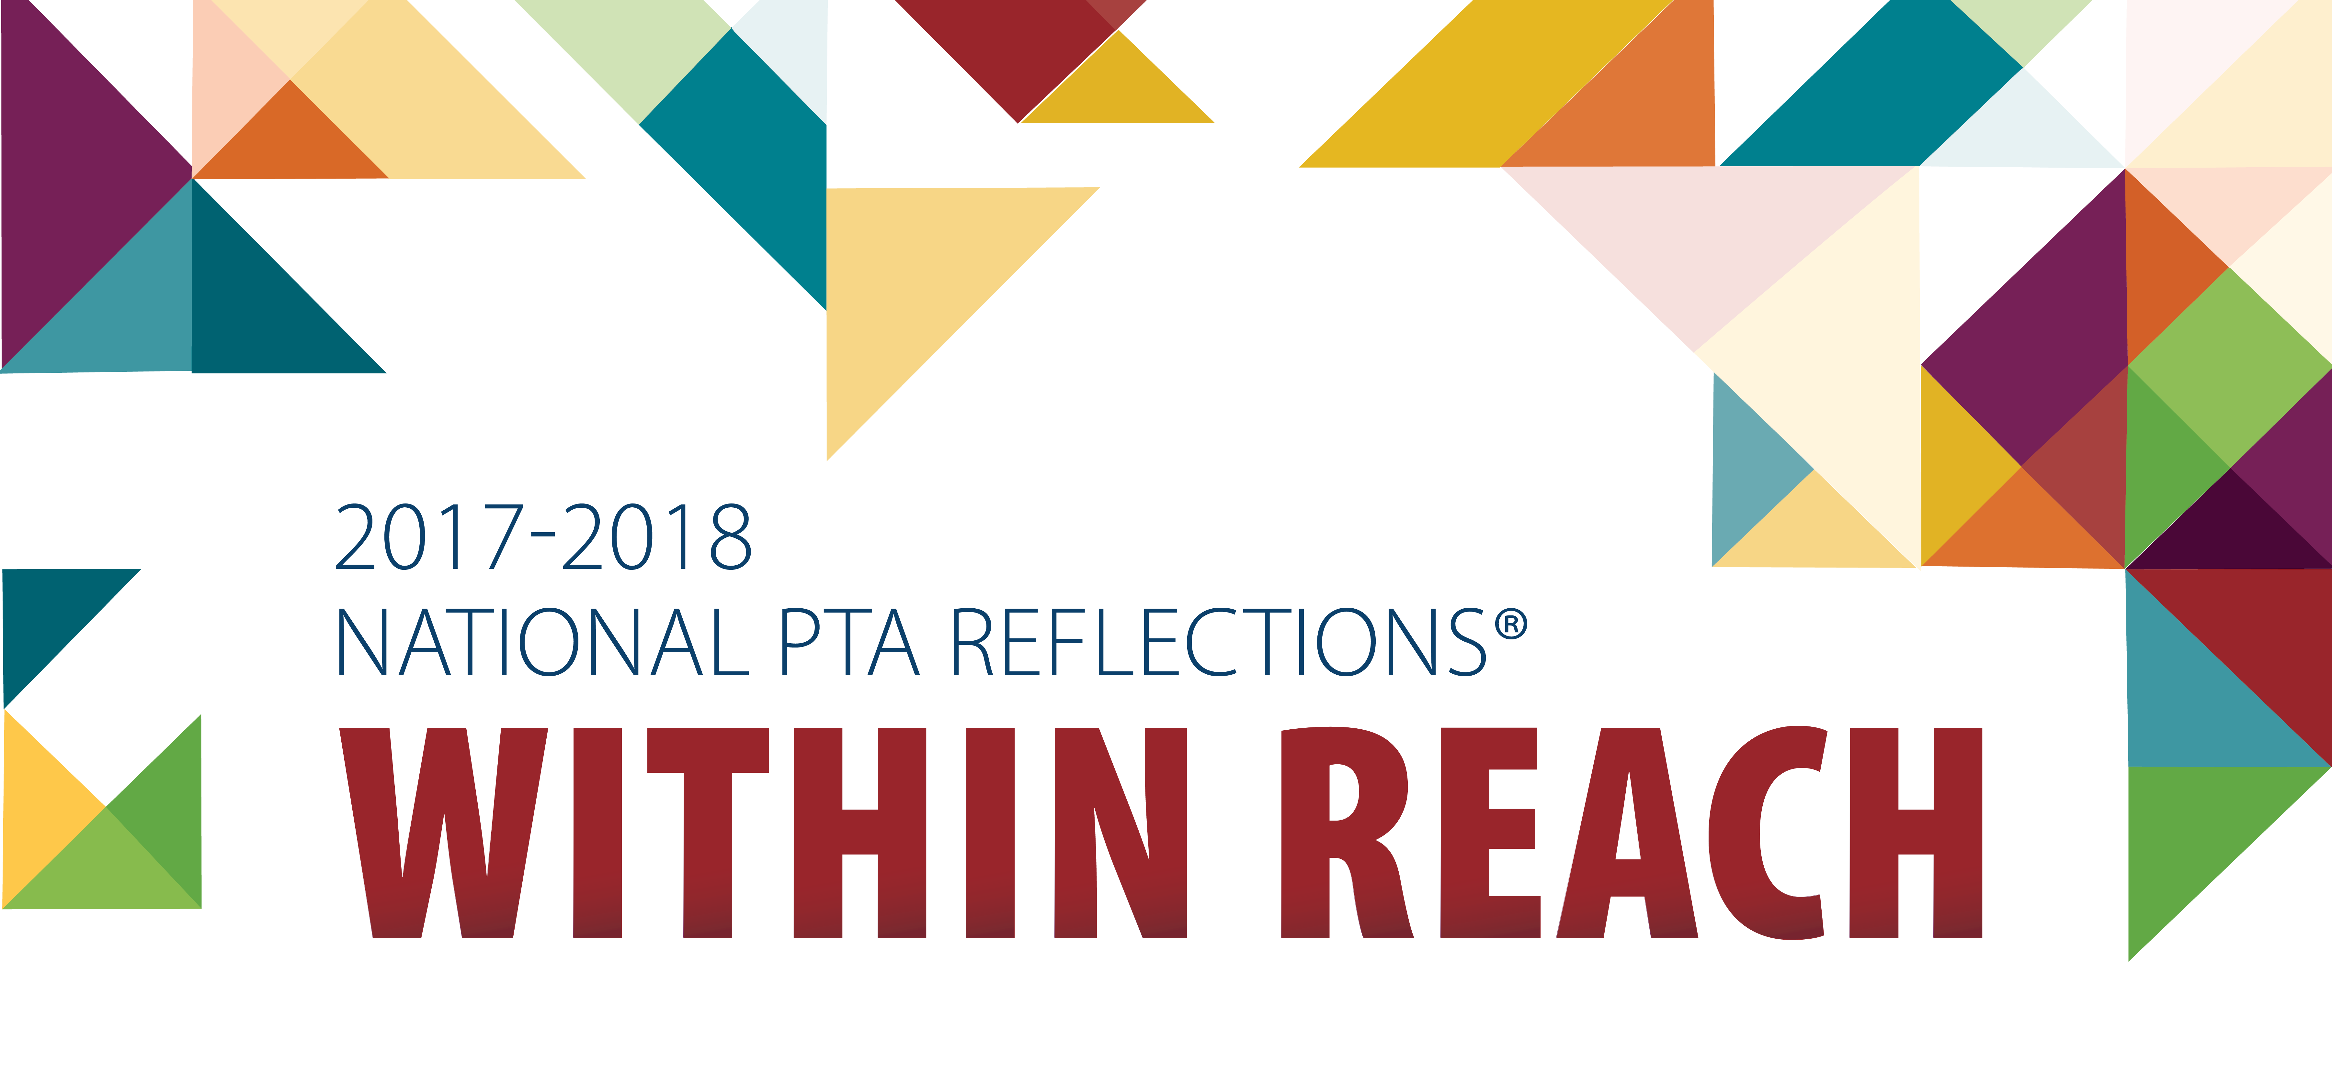

**National PTA Reflections® Program**

***Enter Today!***

**Judging:**

Entries are judged on interpretation of the theme and artistic, creative, and technical merits. Neuqua Valley High School students will be judged at the Senior Level, which includes grades 9 through 12.

**Recognition:**

Students are recognized for their artistic efforts and achievements at the local, regional, state, and national levels of the competition.

**Awards:**

Many outstanding students have represented Neuqua Valley High School in the past. A number of our students have advanced to the state and national levels of the competition, where selected works can receive medals and cash prizes, be recognized at the State and National PTA Annual Conventions and Exhibitions, and win a spot in the exhibit at the U.S. Department of Education in Washington, D.C.

**Official Entry Form:**

A completed official entry form must accompany each piece of art and can easily be found on this NVHS PTSA official web site.

**Rules:**

The official rules for each category can easily be found on this NVHS PTSA official web site.

**Deadline:**

Entries must be received no later than ***3:30 PM Wednesday November 1, 2017***, and can be submitted to the main offices of both the blue and gold campuses.

**Questions?** Please refer to the general rules of the program, as well as to the rules for each arts category on the NVHS PTSA official web site. You can also contact Crystal Nelson at crystalnelson103@gmail.com or 614-648-5454 (cell).

The Deadline for Entries is Friday, October 26

In its 40 year history, the Reflections Program has inspired millions of students across the nation and in American schools overseas to create works of art for fun and recognition.

This is an extracurricular activity that urges students to express themselves as they explore the arts.

Students in preschool through grade 12 are encouraged to create and submit works of art in six different categories: dance choreography, film production, literature, music composition, photography, and visual arts, based on the 2017-18 theme:

***Within Reach***

**Dance ChoreographyFilm ProductionLiterature**

**Music CompositionPhotographyVisual Arts**