Be a Part of PTA’s Reflections® Program
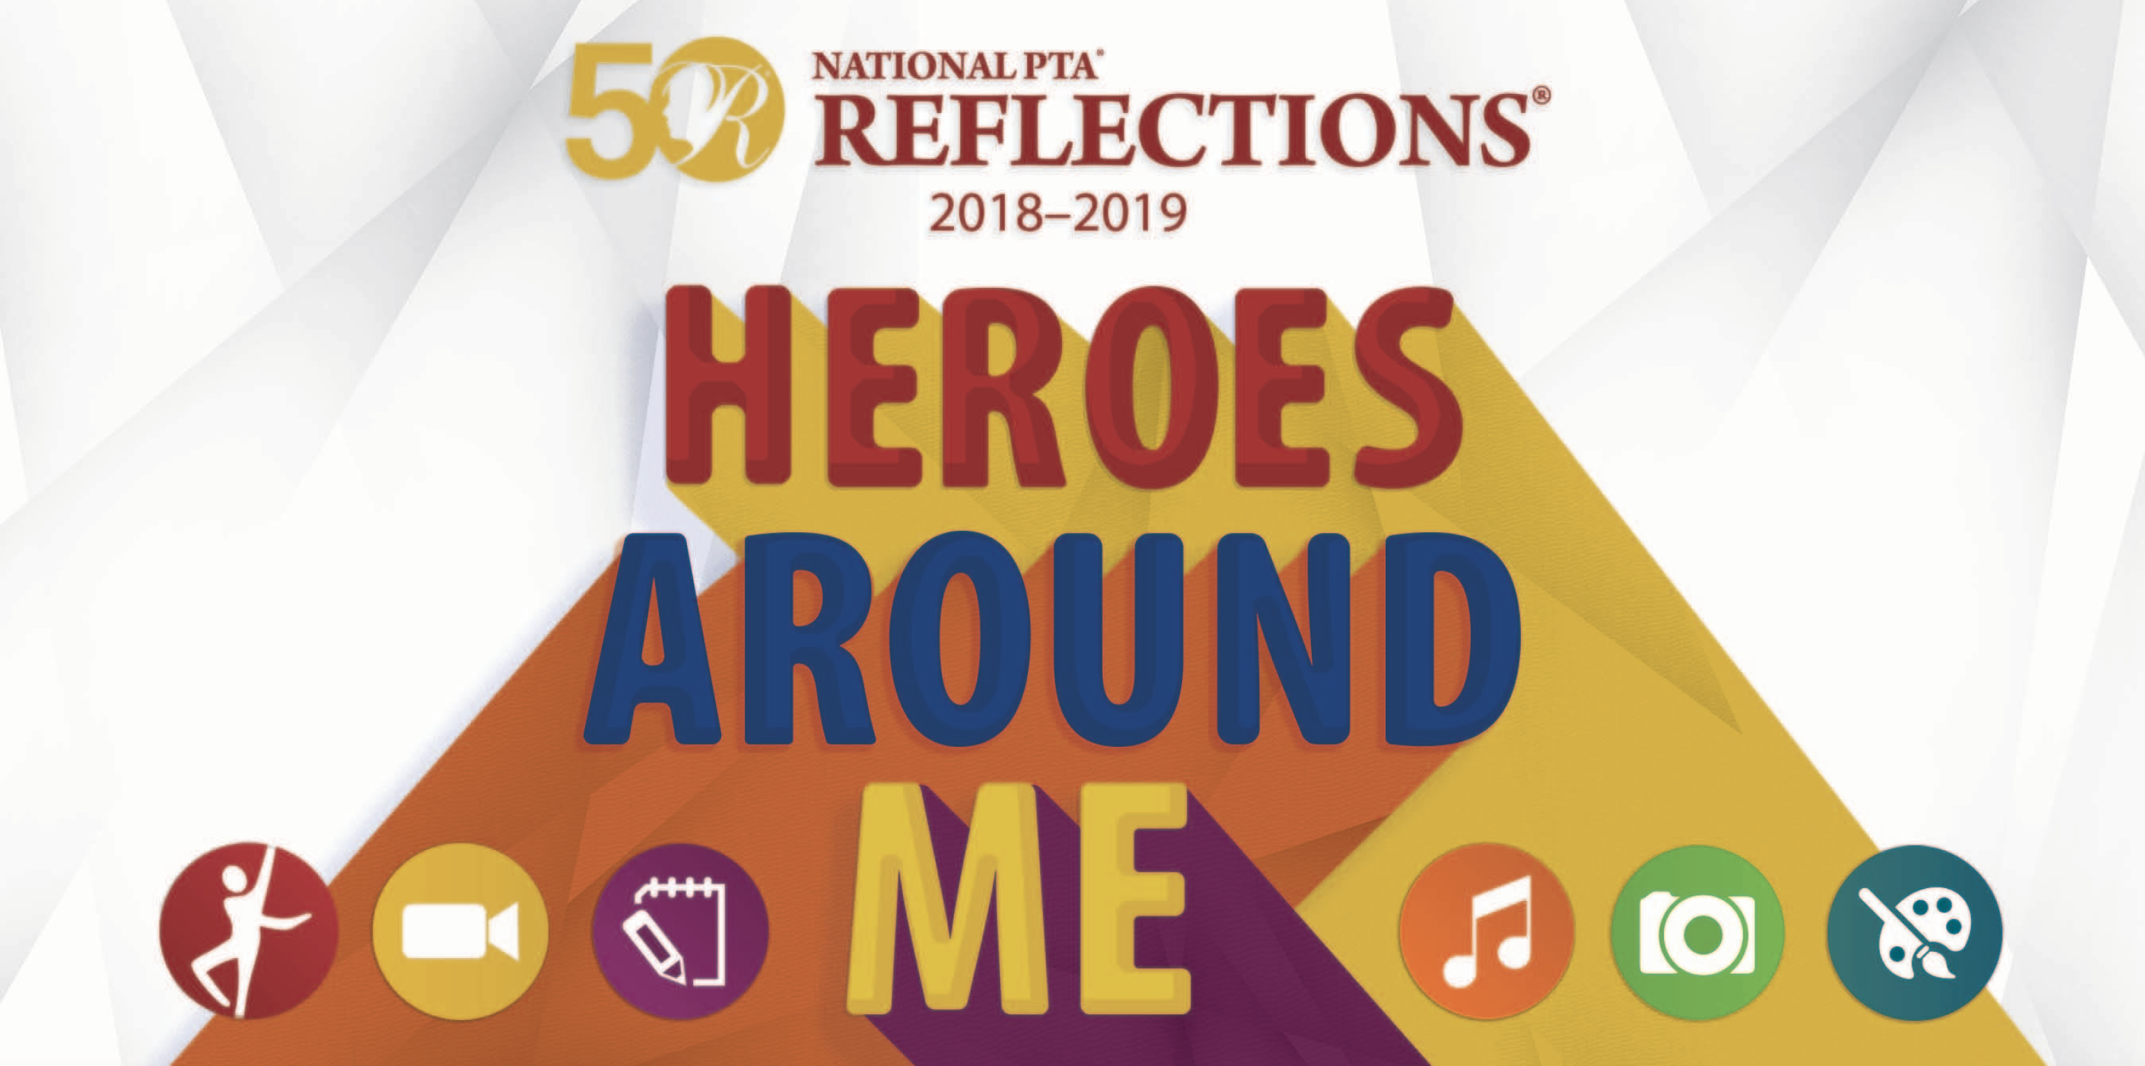
Dance ChoreographyFilm ProductionLiterature
Entries from all grades and all abilities welcome.
Music CompositionPhotographyVisual Arts

Submit entries to the Main Office by
3:30 Wednesday November 7, 2018

See the PTSA web site for details
or contact Crystal Nelson at crystalnelson103@gmail.com

